**BASH SCRIPT 2**

**1) Create on Bash script to check if a directory is available or not.**

**2) Create a bash script which will create multiple files.**

**3) Create a bash script to take backup of a directory.**

**4) Create a bash script to install nginx in ec2 server.**

**5) Create a bash script to install ApacheTomcat in ec2 server.**

**6) Create a bash script to check list if nginx service is running or not,if not running**

**then script should start the service.**

**7) Create a bash script for calculator.**

**8) Create a bash script to check if directory is avaialble or not,if not then create a directory.**

**9) Create bash script to delete last 3 lines for a file.**

**10) Bash script to monitor cpu and if it is more than 80% then send email notification.**

**11) Bash script to monitor disk space and if it is more than 80% then send email notification..**

**12) Bash script to monitor memory and if it is more than 80% then send email notification.**

**1) Create on Bash script to check if a directory is available or not.**

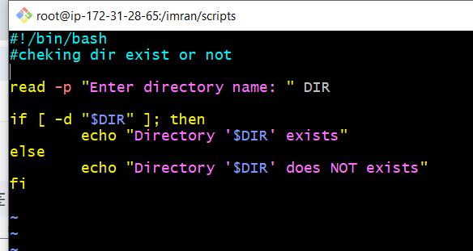

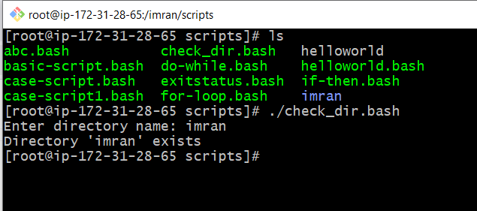

**2) Create a bash script which will create multiple files.**

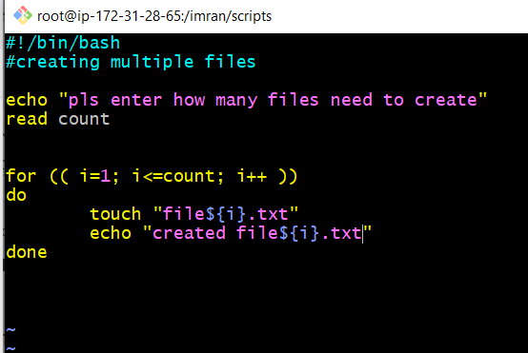

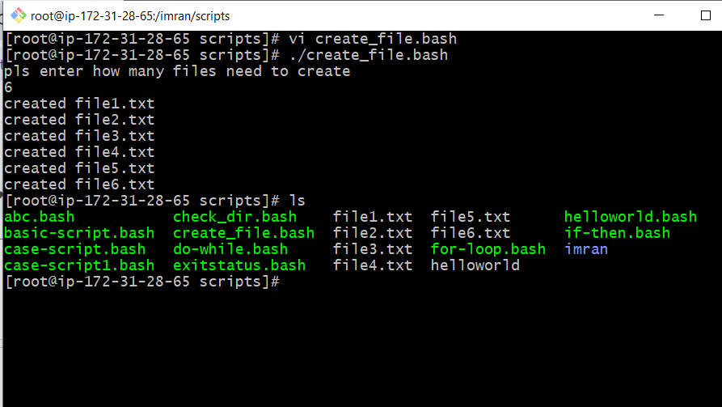

**3) Create a bash script to take backup of a directory.**

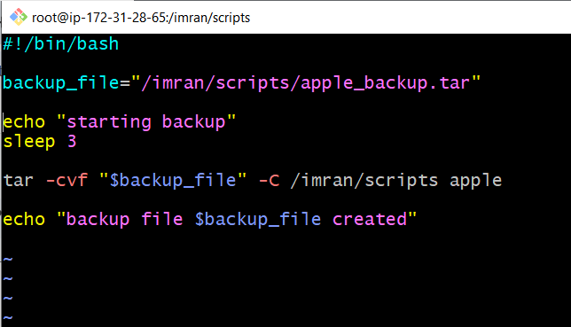

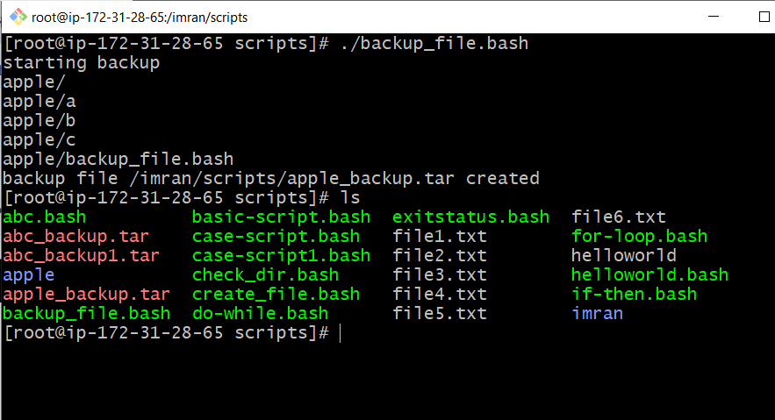

**4) Create a bash script to install nginx in ec2 server.**

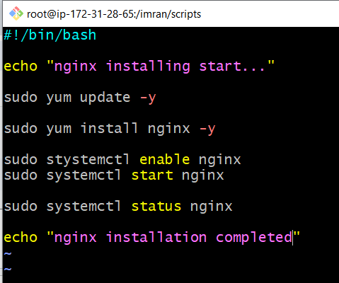

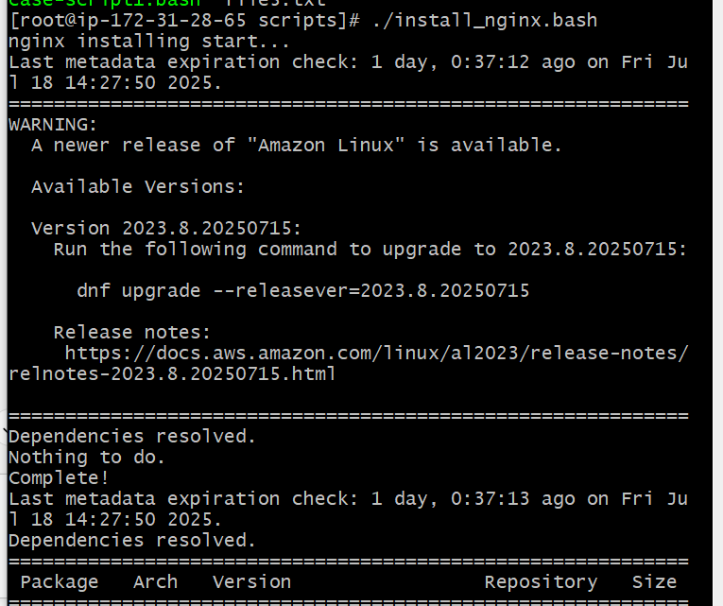

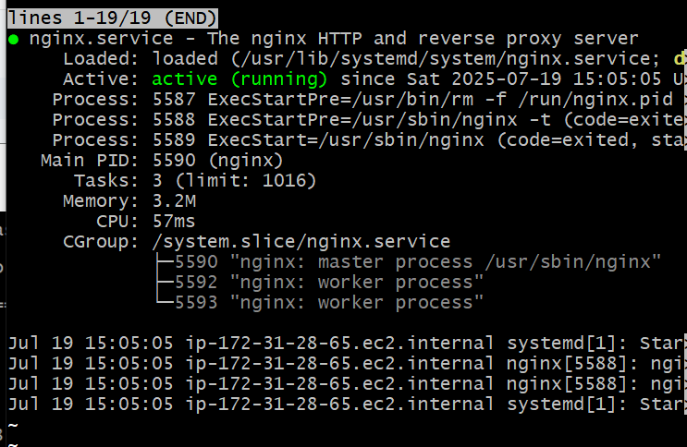

**5) Create a bash script to install ApacheTomcat in ec2 server.**

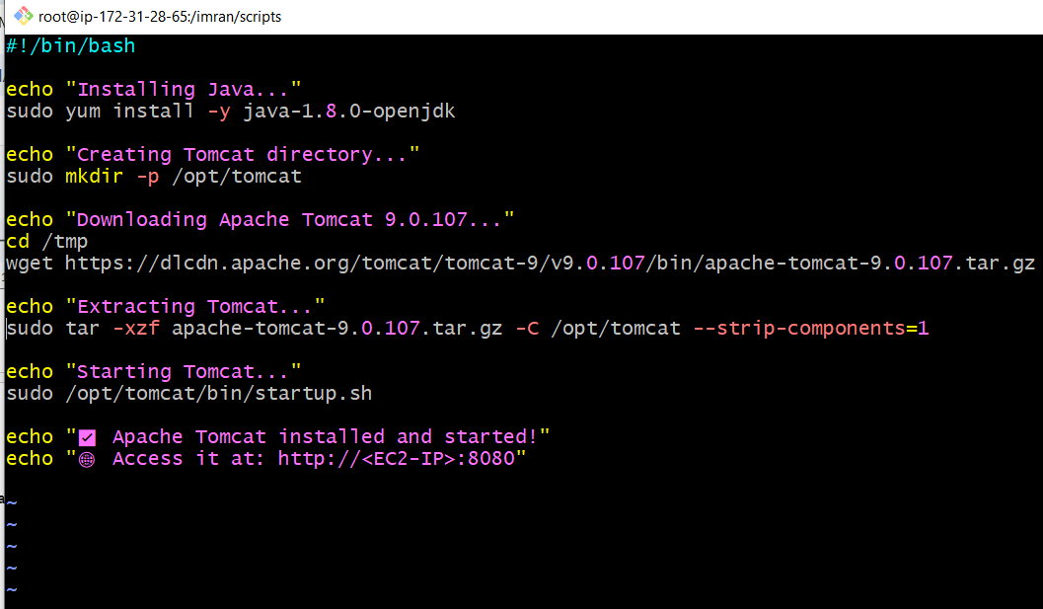

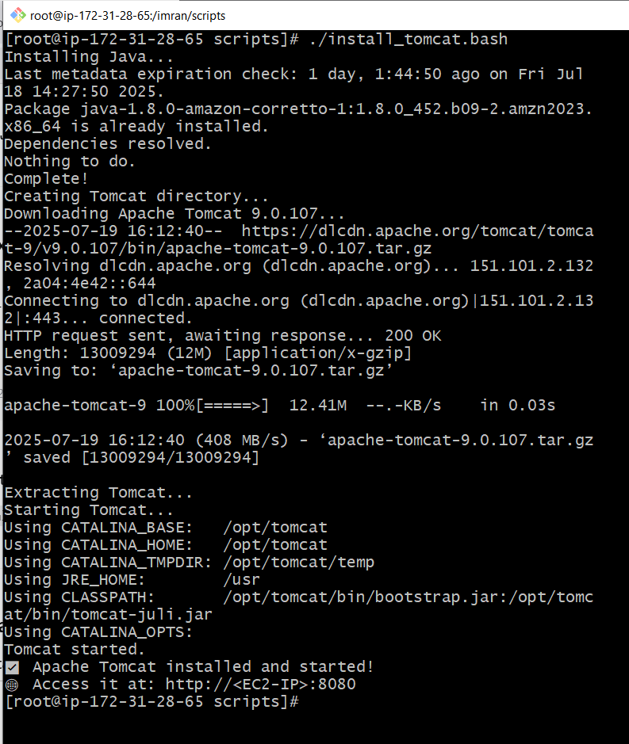

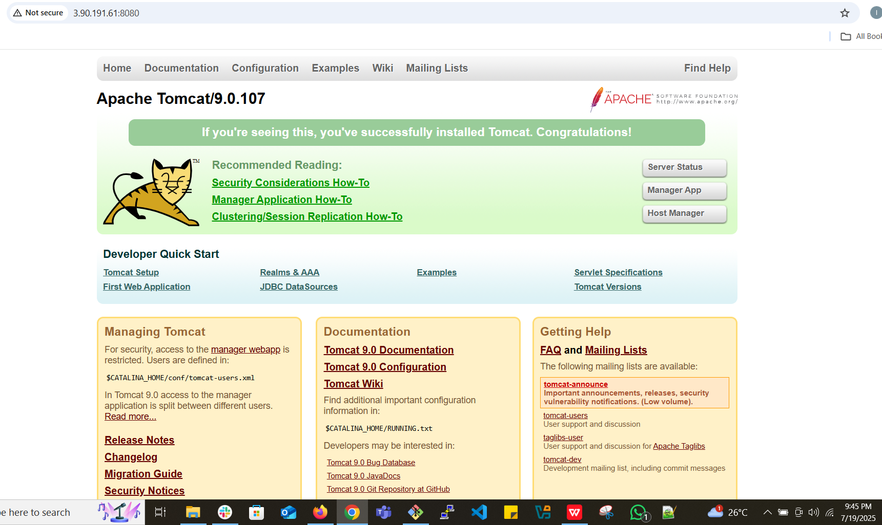

**6) Create a bash script to check list if nginx service is running or not,if not running**

**then script should start the service.**

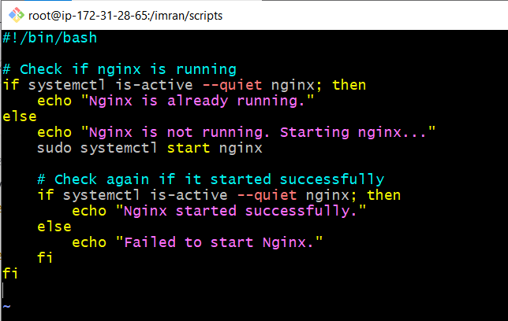

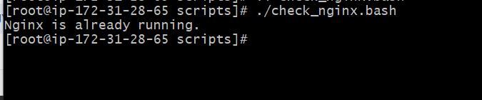

**7) Create a bash script for calculator.**

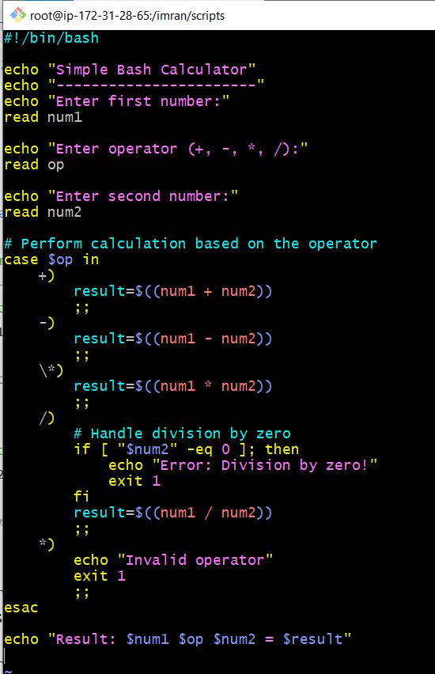

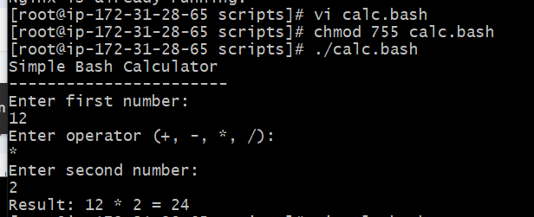

**8) Create a bash script to check if directory is avaialble or not,if not then create a directory.**

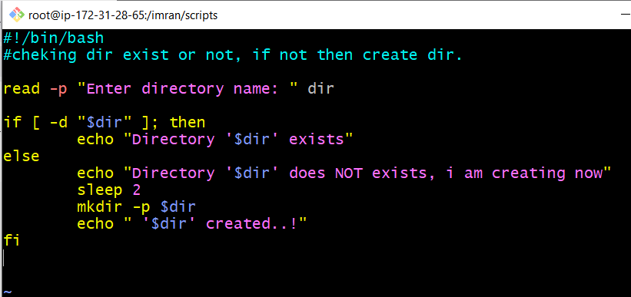

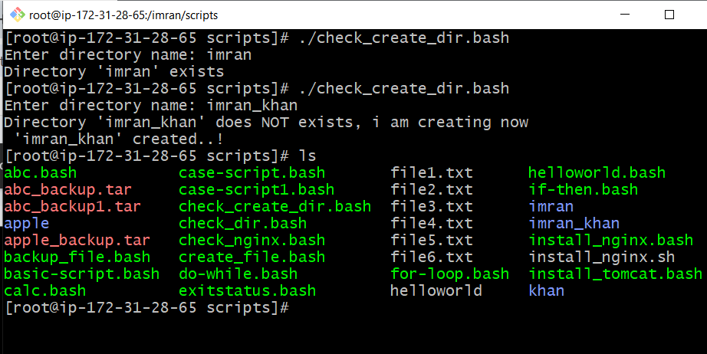

**9) Create bash script to delete last 3 lines for a file.**

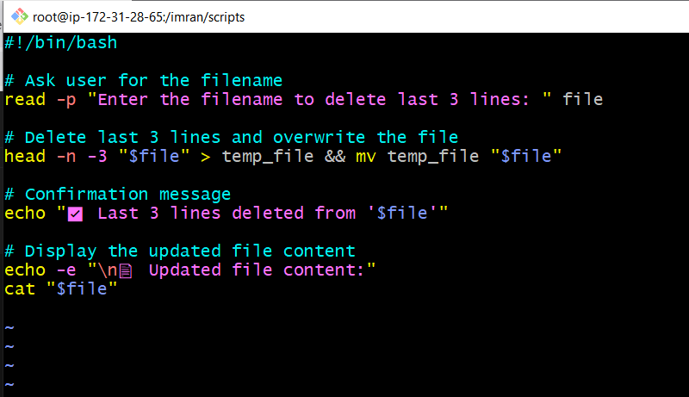

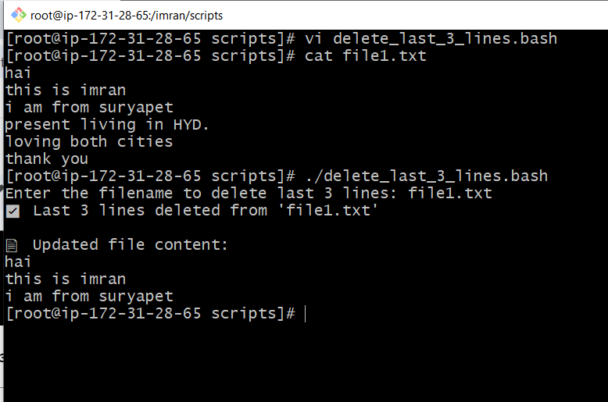

**10) Bash script to monitor cpu and if it is more than 80% then send email notification.**

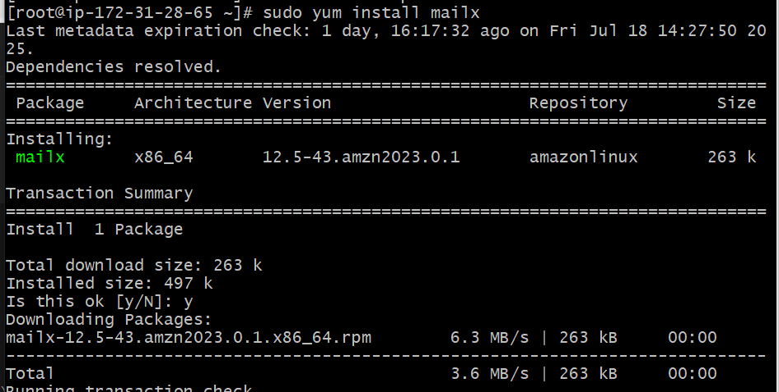

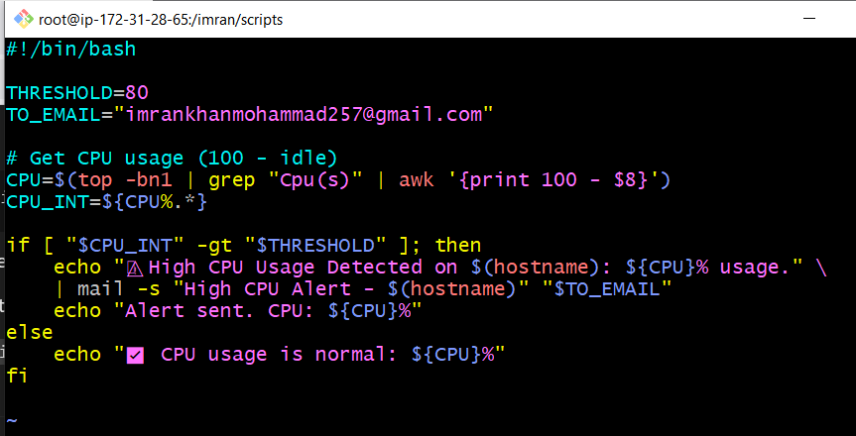

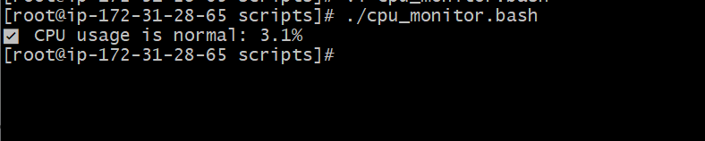

**11) Bash script to monitor disk space and if it is more than 80% then send email notification..**

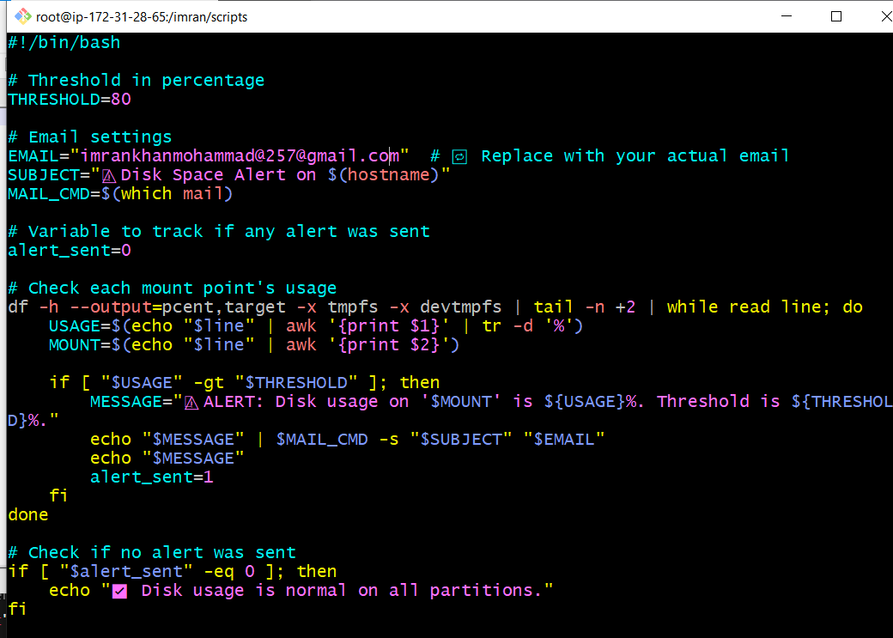

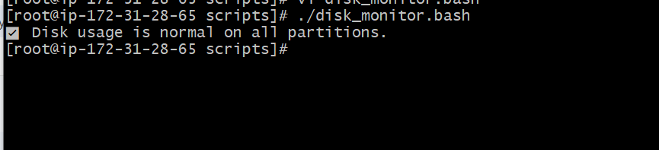

**12) Bash script to monitor memory and if it is more than 80% then send email notification.**

